Frequencies

Statistics
 |  | X1 | X2 | X3 | X4 | X5 | X6 | X7
N | Valid | 20 | 20 | 20 | 20 | 20 | 20 | 20
N | Missing | 0 | 0 | 0 | 0 | 0 | 0 | 0
Mean |  | 2,8500 | 2,7000 | 2,7500 | 2,6500 | 2,7000 | 2,9000 | 2,7000
Std. Error of Mean |  | ,28354 | ,30000 | ,31519 | ,25418 | ,29110 | ,27048 | ,27242
Median |  | 2,5000 | 2,5000 | 2,0000 | 2,0000 | 2,0000 | 2,5000 | 3,0000
Mode |  | 2,00 | 2,00 | 2,00 | 2,00 | 2,00 | 2,00 | 3,00
Std. Deviation |  | 1,26803 | 1,34164 | 1,40955 | 1,13671 | 1,30182 | 1,20961 | 1,21828
Variance |  | 1,608 | 1,800 | 1,987 | 1,292 | 1,695 | 1,463 | 1,484
Range |  | 4,00 | 4,00 | 4,00 | 4,00 | 4,00 | 4,00 | 4,00
Minimum |  | 1,00 | 1,00 | 1,00 | 1,00 | 1,00 | 1,00 | 1,00
Maximum |  | 5,00 | 5,00 | 5,00 | 5,00 | 5,00 | 5,00 | 5,00
Sum |  | 57,00 | 54,00 | 55,00 | 53,00 | 54,00 | 58,00 | 54,00

Statistics
 |  | X8
N | Valid | 20
N | Missing | 0
Mean |  | 3,2000
Std. Error of Mean |  | ,25752
Median |  | 3,0000
Mode |  | 3,00
Std. Deviation |  | 1,15166
Variance |  | 1,326
Range |  | 4,00
Minimum |  | 1,00
Maximum |  | 5,00
Sum |  | 64,00

Frequency Table

X1
 |  | Frequency | Percent | Valid Percent | Cumulative Percent
Valid | Sangat Tidak Puas | 2 | 10,0 | 10,0 | 10,0
Valid | Tidak Puas | 8 | 40,0 | 40,0 | 50,0
Valid | Kurang Puas | 4 | 20,0 | 20,0 | 70,0
Valid | Puas | 3 | 15,0 | 15,0 | 85,0
Valid | Sangat Puas | 3 | 15,0 | 15,0 | 100,0
Valid | Total | 20 | 100,0 | 100,0

X2
 |  | Frequency | Percent | Valid Percent | Cumulative Percent
Valid | Sangat Tidak Puas | 4 | 20,0 | 20,0 | 20,0
Valid | Tidak Puas | 6 | 30,0 | 30,0 | 50,0
Valid | Kurang Puas | 5 | 25,0 | 25,0 | 75,0
Valid | Puas | 2 | 10,0 | 10,0 | 85,0
Valid | Sangat Puas | 3 | 15,0 | 15,0 | 100,0
Valid | Total | 20 | 100,0 | 100,0

X3
 |  | Frequency | Percent | Valid Percent | Cumulative Percent
Valid | Sangat Tidak Puas | 3 | 15,0 | 15,0 | 15,0
Valid | Tidak Puas | 9 | 45,0 | 45,0 | 60,0
Valid | Kurang Puas | 2 | 10,0 | 10,0 | 70,0
Valid | Puas | 2 | 10,0 | 10,0 | 80,0
Valid | Sangat Puas | 4 | 20,0 | 20,0 | 100,0
Valid | Total | 20 | 100,0 | 100,0

X4
 |  | Frequency | Percent | Valid Percent | Cumulative Percent
Valid | Sangat Tidak Puas | 2 | 10,0 | 10,0 | 10,0
Valid | Tidak Puas | 9 | 45,0 | 45,0 | 55,0
Valid | Kurang Puas | 5 | 25,0 | 25,0 | 80,0
Valid | Puas | 2 | 10,0 | 10,0 | 90,0
Valid | Sangat Puas | 2 | 10,0 | 10,0 | 100,0
Valid | Total | 20 | 100,0 | 100,0

X5
 |  | Frequency | Percent | Valid Percent | Cumulative Percent
Valid | Sangat Tidak Puas | 3 | 15,0 | 15,0 | 15,0
Valid | Tidak Puas | 8 | 40,0 | 40,0 | 55,0
Valid | Kurang Puas | 4 | 20,0 | 20,0 | 75,0
Valid | Puas | 2 | 10,0 | 10,0 | 85,0
Valid | Sangat Puas | 3 | 15,0 | 15,0 | 100,0
Valid | Total | 20 | 100,0 | 100,0

X6
 |  | Frequency | Percent | Valid Percent | Cumulative Percent
Valid | Sangat Tidak Puas | 1 | 5,0 | 5,0 | 5,0
Valid | Tidak Puas | 9 | 45,0 | 45,0 | 50,0
Valid | Kurang Puas | 4 | 20,0 | 20,0 | 70,0
Valid | Puas | 3 | 15,0 | 15,0 | 85,0
Valid | Sangat Puas | 3 | 15,0 | 15,0 | 100,0
Valid | Total | 20 | 100,0 | 100,0

X7
 |  | Frequency | Percent | Valid Percent | Cumulative Percent
Valid | Sangat Tidak Puas | 4 | 20,0 | 20,0 | 20,0
Valid | Tidak Puas | 4 | 20,0 | 20,0 | 40,0
Valid | Kurang Puas | 8 | 40,0 | 40,0 | 80,0
Valid | Puas | 2 | 10,0 | 10,0 | 90,0
Valid | Sangat Puas | 2 | 10,0 | 10,0 | 100,0
Valid | Total | 20 | 100,0 | 100,0

X8
 |  | Frequency | Percent | Valid Percent | Cumulative Percent
Valid | Sangat Tidak Puas | 1 | 5,0 | 5,0 | 5,0
Valid | Tidak Puas | 5 | 25,0 | 25,0 | 30,0
Valid | Kurang Puas | 6 | 30,0 | 30,0 | 60,0
Valid | Puas | 5 | 25,0 | 25,0 | 85,0
Valid | Sangat Puas | 3 | 15,0 | 15,0 | 100,0
Valid | Total | 20 | 100,0 | 100,0

Pie Chart

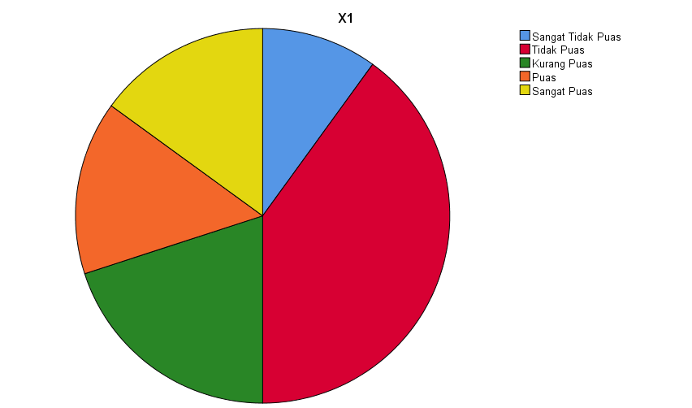

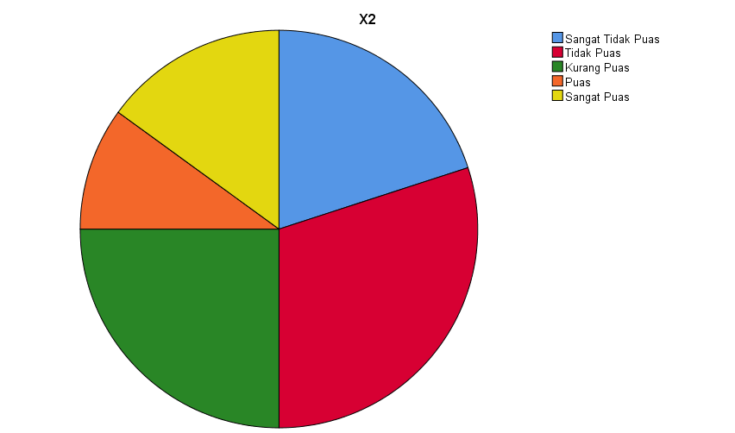

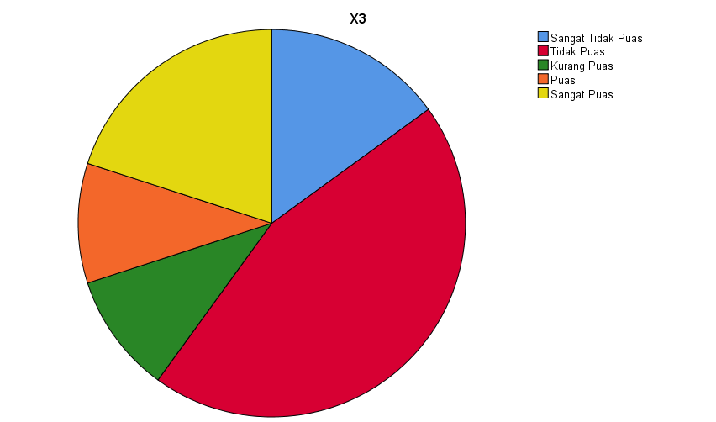

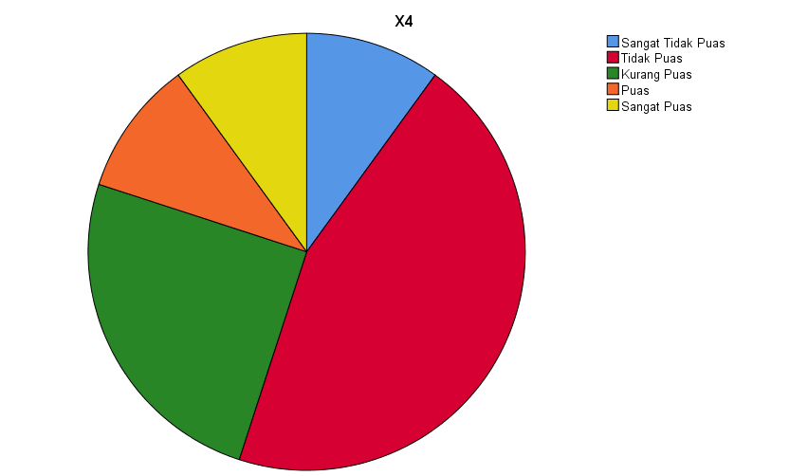

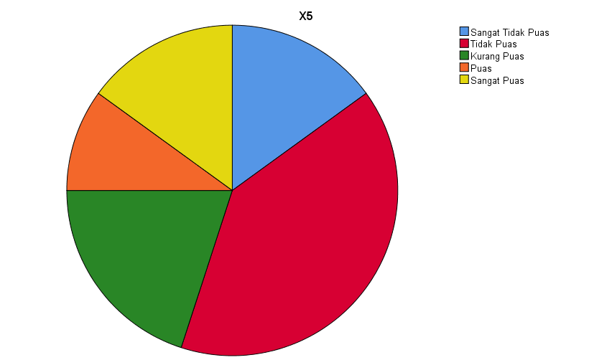

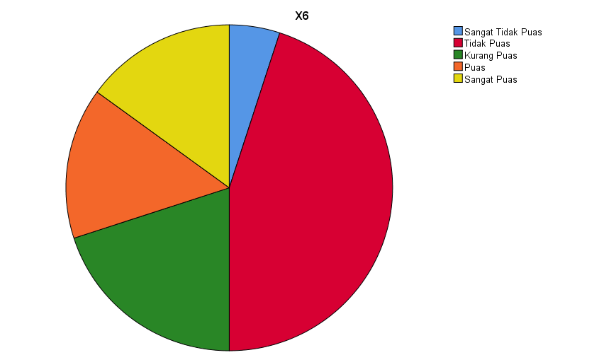

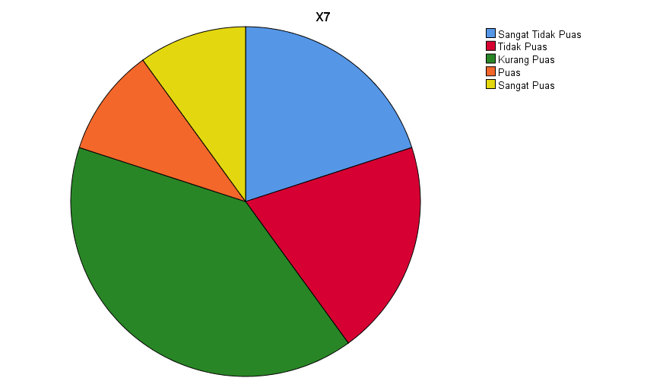

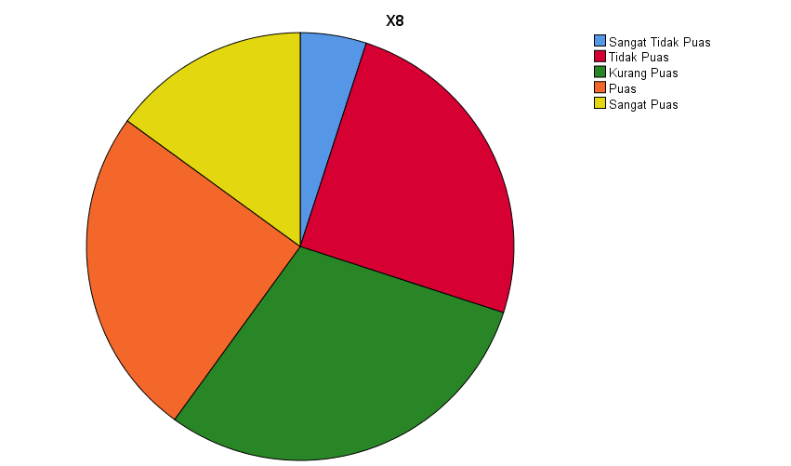

CROSSTABS
/TABLES=X1 BY X2 X3 X4 X5 X6 X7 X8
/FORMAT=NOTABLES
/COUNT ROUND CELL
/BARCHART.

Crosstabs

Case Processing Summary
 | Cases
 | Valid |  | Missing |  | Total
 | N | Percent | N | Percent | N | Percent
X1 * X2 | 20 | 100,0% | 0 | 0,0% | 20 | 100,0%
X1 * X3 | 20 | 100,0% | 0 | 0,0% | 20 | 100,0%
X1 * X4 | 20 | 100,0% | 0 | 0,0% | 20 | 100,0%
X1 * X5 | 20 | 100,0% | 0 | 0,0% | 20 | 100,0%
X1 * X6 | 20 | 100,0% | 0 | 0,0% | 20 | 100,0%
X1 * X7 | 20 | 100,0% | 0 | 0,0% | 20 | 100,0%
X1 * X8 | 20 | 100,0% | 0 | 0,0% | 20 | 100,0%

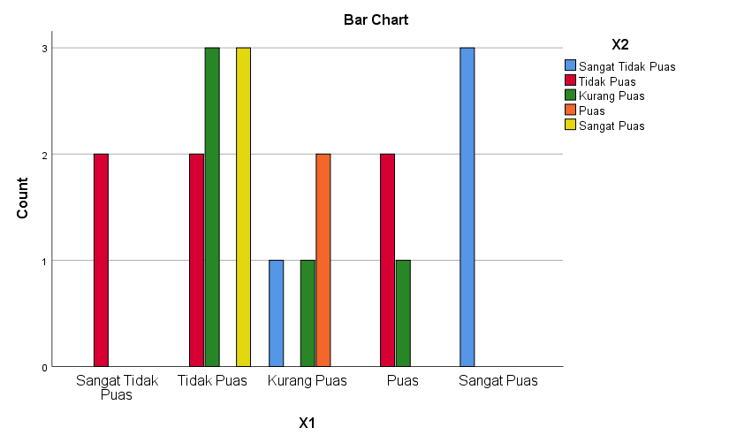

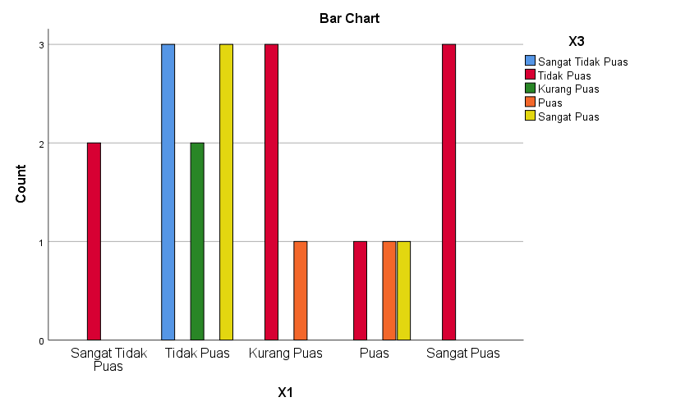

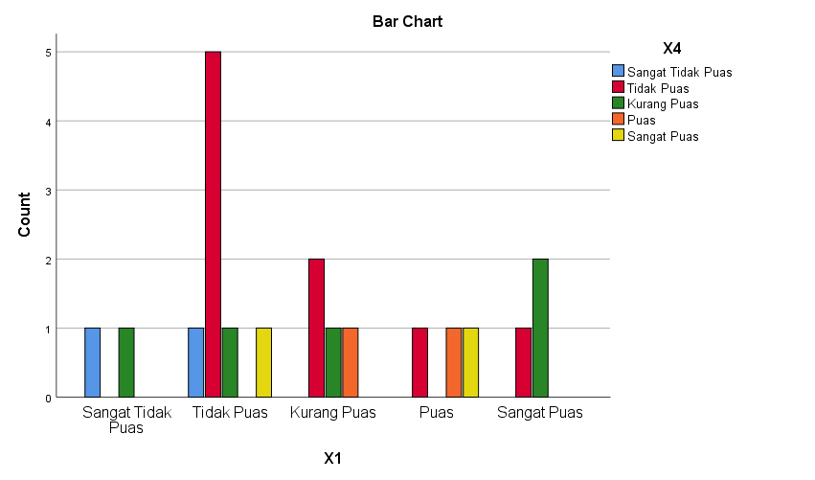

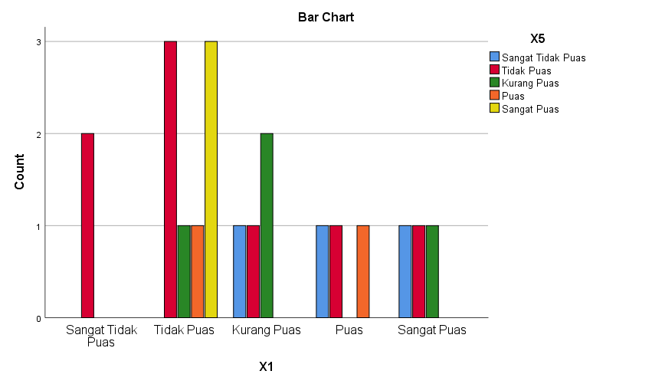

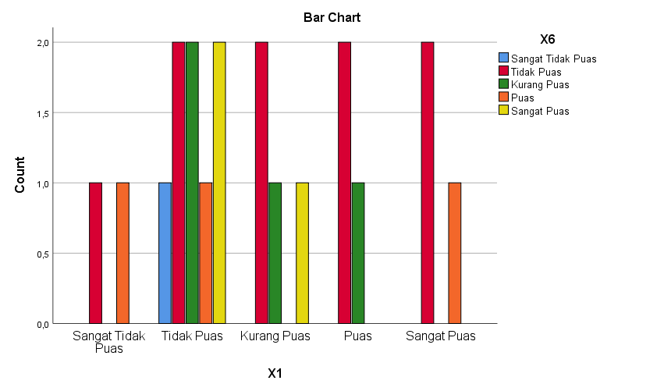

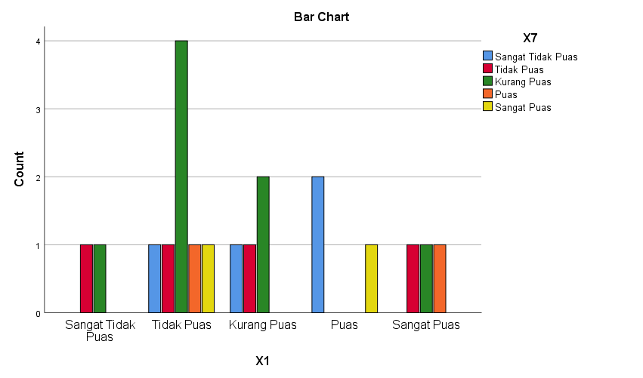

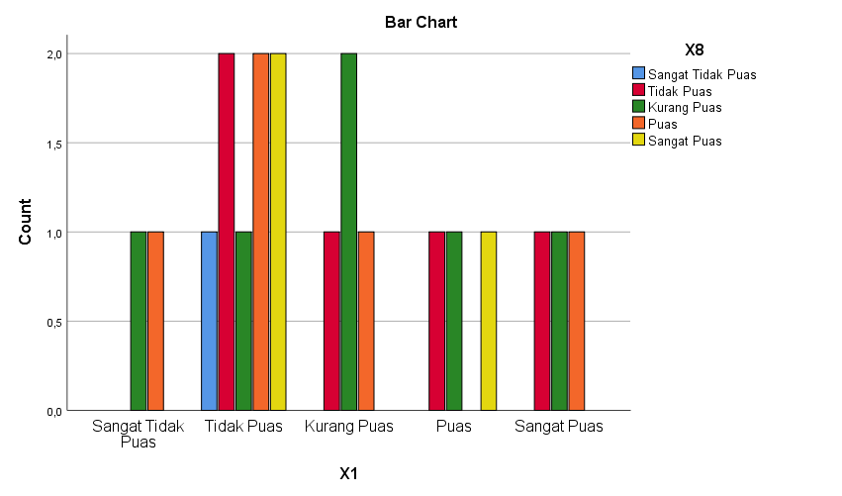

DATASET ACTIVATE DataSet1.
FREQUENCIES VARIABLES=Y1 Y2 Y3 Y4 Y5 Y6 Y7 Y8
/STATISTICS=STDDEV VARIANCE RANGE MINIMUM MAXIMUM SEMEAN MEAN MEDIAN MODE SUM
/PIECHART FREQ
/ORDER=ANALYSIS.

Frequencies

[DataSet1]

Statistics
 |  | Y1 | Y2 | Y3 | Y4 | Y5 | Y6 | Y7
N | Valid | 20 | 20 | 20 | 20 | 20 | 20 | 20
N | Missing | 0 | 0 | 0 | 0 | 0 | 0 | 0
Mean |  | 2,7000 | 2,9500 | 2,9500 | 2,9000 | 2,8500 | 2,8500 | 3,0000
Std. Error of Mean |  | ,25236 | ,30327 | ,29447 | ,28928 | ,28354 | ,29267 | ,28098
Median |  | 2,0000 | 2,5000 | 2,5000 | 2,0000 | 2,5000 | 2,0000 | 2,5000
Mode |  | 2,00 | 2,00 | 2,00 | 2,00 | 2,00 | 2,00 | 2,00
Std. Deviation |  | 1,12858 | 1,35627 | 1,31689 | 1,29371 | 1,26803 | 1,30888 | 1,25656
Variance |  | 1,274 | 1,839 | 1,734 | 1,674 | 1,608 | 1,713 | 1,579
Range |  | 4,00 | 4,00 | 4,00 | 4,00 | 4,00 | 4,00 | 4,00
Minimum |  | 1,00 | 1,00 | 1,00 | 1,00 | 1,00 | 1,00 | 1,00
Maximum |  | 5,00 | 5,00 | 5,00 | 5,00 | 5,00 | 5,00 | 5,00
Sum |  | 54,00 | 59,00 | 59,00 | 58,00 | 57,00 | 57,00 | 60,00

Statistics
 |  | Y8
N | Valid | 20
N | Missing | 0
Mean |  | 2,7000
Std. Error of Mean |  | ,26258
Median |  | 2,0000
Mode |  | 2,00
Std. Deviation |  | 1,17429
Variance |  | 1,379
Range |  | 4,00
Minimum |  | 1,00
Maximum |  | 5,00
Sum |  | 54,00

Frequency Table

Y1
 |  | Frequency | Percent | Valid Percent | Cumulative Percent
Valid | Sangat Tidak Puas | 1 | 5,0 | 5,0 | 5,0
Valid | Tidak Puas | 11 | 55,0 | 55,0 | 60,0
Valid | Kurang Puas | 3 | 15,0 | 15,0 | 75,0
Valid | Puas | 3 | 15,0 | 15,0 | 90,0
Valid | Sangat Puas | 2 | 10,0 | 10,0 | 100,0
Valid | Total | 20 | 100,0 | 100,0

Y2
 |  | Frequency | Percent | Valid Percent | Cumulative Percent
Valid | Sangat Tidak Puas | 2 | 10,0 | 10,0 | 10,0
Valid | Tidak Puas | 8 | 40,0 | 40,0 | 50,0
Valid | Kurang Puas | 3 | 15,0 | 15,0 | 65,0
Valid | Puas | 3 | 15,0 | 15,0 | 80,0
Valid | Sangat Puas | 4 | 20,0 | 20,0 | 100,0
Valid | Total | 20 | 100,0 | 100,0

Y3
 |  | Frequency | Percent | Valid Percent | Cumulative Percent
Valid | Sangat Tidak Puas | 2 | 10,0 | 10,0 | 10,0
Valid | Tidak Puas | 8 | 40,0 | 40,0 | 50,0
Valid | Kurang Puas | 2 | 10,0 | 10,0 | 60,0
Valid | Puas | 5 | 25,0 | 25,0 | 85,0
Valid | Sangat Puas | 3 | 15,0 | 15,0 | 100,0
Valid | Total | 20 | 100,0 | 100,0

Y4
 |  | Frequency | Percent | Valid Percent | Cumulative Percent
Valid | Sangat Tidak Puas | 1 | 5,0 | 5,0 | 5,0
Valid | Tidak Puas | 10 | 50,0 | 50,0 | 55,0
Valid | Kurang Puas | 3 | 15,0 | 15,0 | 70,0
Valid | Puas | 2 | 10,0 | 10,0 | 80,0
Valid | Sangat Puas | 4 | 20,0 | 20,0 | 100,0
Valid | Total | 20 | 100,0 | 100,0

Y5
 |  | Frequency | Percent | Valid Percent | Cumulative Percent
Valid | Sangat Tidak Puas | 2 | 10,0 | 10,0 | 10,0
Valid | Tidak Puas | 8 | 40,0 | 40,0 | 50,0
Valid | Kurang Puas | 4 | 20,0 | 20,0 | 70,0
Valid | Puas | 3 | 15,0 | 15,0 | 85,0
Valid | Sangat Puas | 3 | 15,0 | 15,0 | 100,0
Valid | Total | 20 | 100,0 | 100,0

Y6
 |  | Frequency | Percent | Valid Percent | Cumulative Percent
Valid | Sangat Tidak Puas | 2 | 10,0 | 10,0 | 10,0
Valid | Tidak Puas | 9 | 45,0 | 45,0 | 55,0
Valid | Kurang Puas | 2 | 10,0 | 10,0 | 65,0
Valid | Puas | 4 | 20,0 | 20,0 | 85,0
Valid | Sangat Puas | 3 | 15,0 | 15,0 | 100,0
Valid | Total | 20 | 100,0 | 100,0

Y7
 |  | Frequency | Percent | Valid Percent | Cumulative Percent
Valid | Sangat Tidak Puas | 1 | 5,0 | 5,0 | 5,0
Valid | Tidak Puas | 9 | 45,0 | 45,0 | 50,0
Valid | Kurang Puas | 2 | 10,0 | 10,0 | 60,0
Valid | Puas | 5 | 25,0 | 25,0 | 85,0
Valid | Sangat Puas | 3 | 15,0 | 15,0 | 100,0
Valid | Total | 20 | 100,0 | 100,0

Y8
 |  | Frequency | Percent | Valid Percent | Cumulative Percent
Valid | Sangat Tidak Puas | 2 | 10,0 | 10,0 | 10,0
Valid | Tidak Puas | 9 | 45,0 | 45,0 | 55,0
Valid | Kurang Puas | 4 | 20,0 | 20,0 | 75,0
Valid | Puas | 3 | 15,0 | 15,0 | 90,0
Valid | Sangat Puas | 2 | 10,0 | 10,0 | 100,0
Valid | Total | 20 | 100,0 | 100,0

Pie Chart

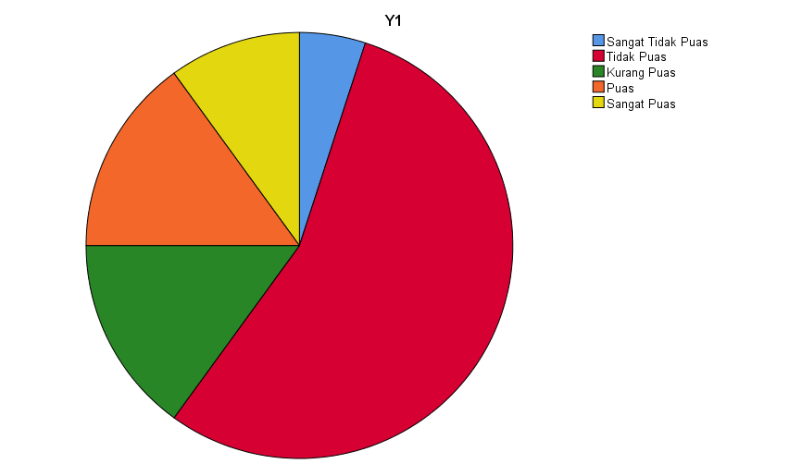

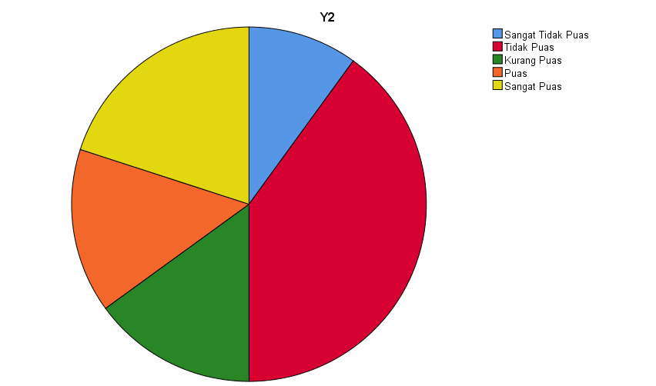

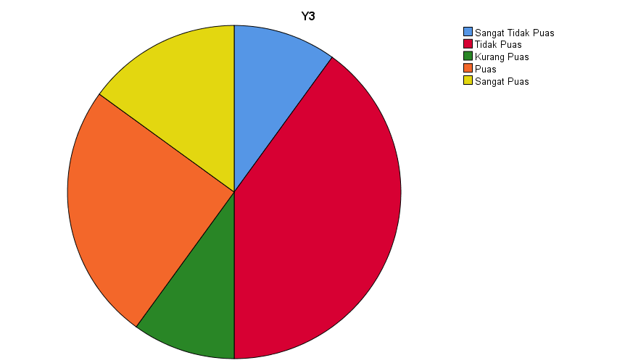

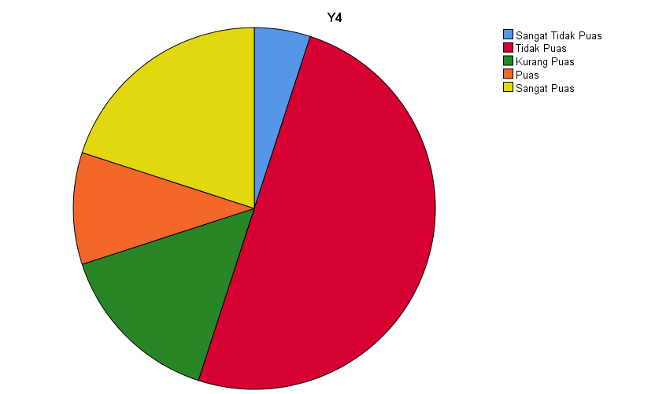

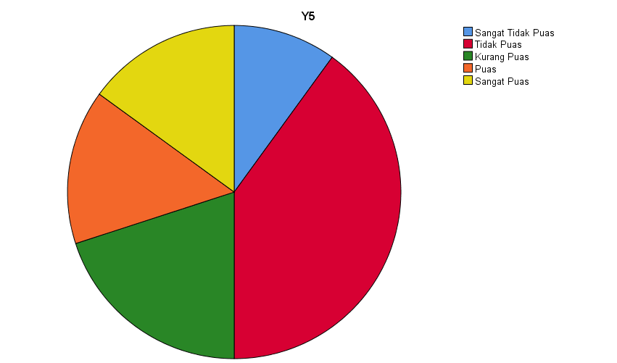

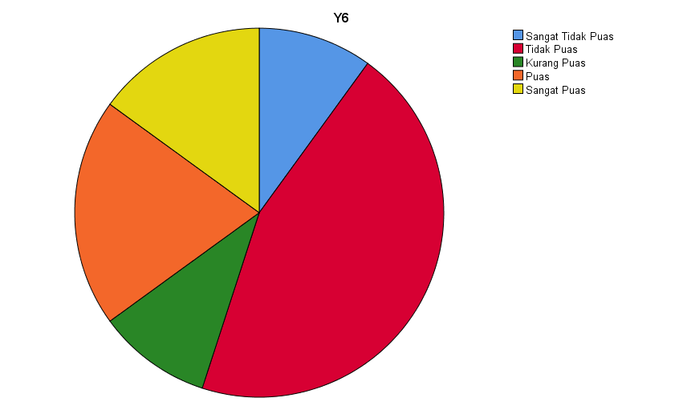

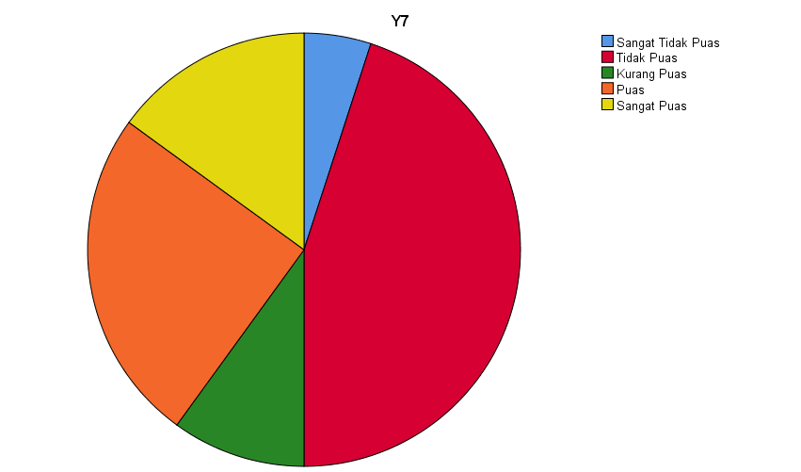

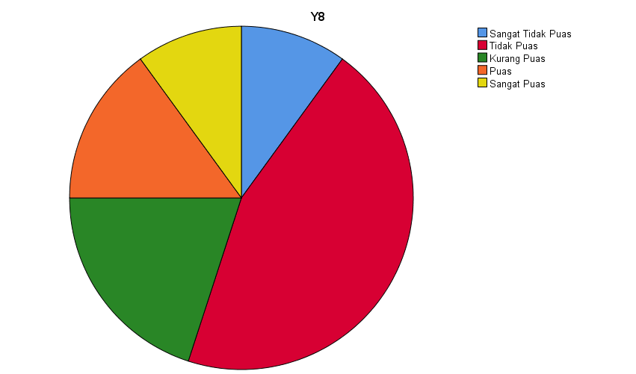

CROSSTABS
/TABLES=Y1 BY Y2 Y3 Y4 Y5 Y6 Y7 Y8
/FORMAT=NOTABLES
/COUNT ROUND CELL
/BARCHART.

Crosstabs

Case Processing Summary
 | Cases
 | Valid |  | Missing |  | Total
 | N | Percent | N | Percent | N | Percent
Y1 * Y2 | 20 | 100,0% | 0 | 0,0% | 20 | 100,0%
Y1 * Y3 | 20 | 100,0% | 0 | 0,0% | 20 | 100,0%
Y1 * Y4 | 20 | 100,0% | 0 | 0,0% | 20 | 100,0%
Y1 * Y5 | 20 | 100,0% | 0 | 0,0% | 20 | 100,0%
Y1 * Y6 | 20 | 100,0% | 0 | 0,0% | 20 | 100,0%
Y1 * Y7 | 20 | 100,0% | 0 | 0,0% | 20 | 100,0%
Y1 * Y8 | 20 | 100,0% | 0 | 0,0% | 20 | 100,0%

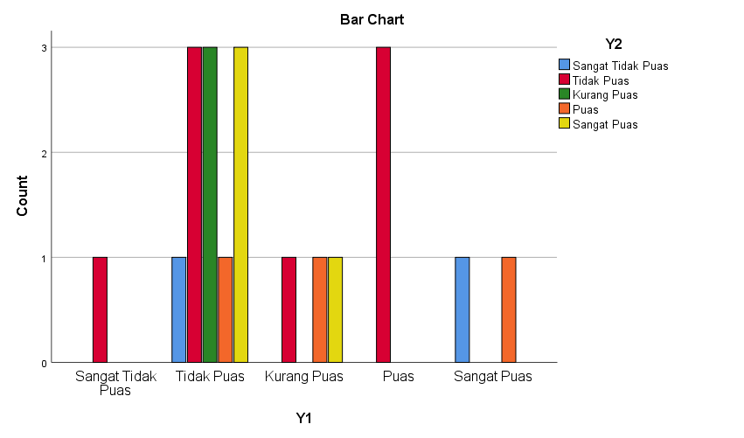

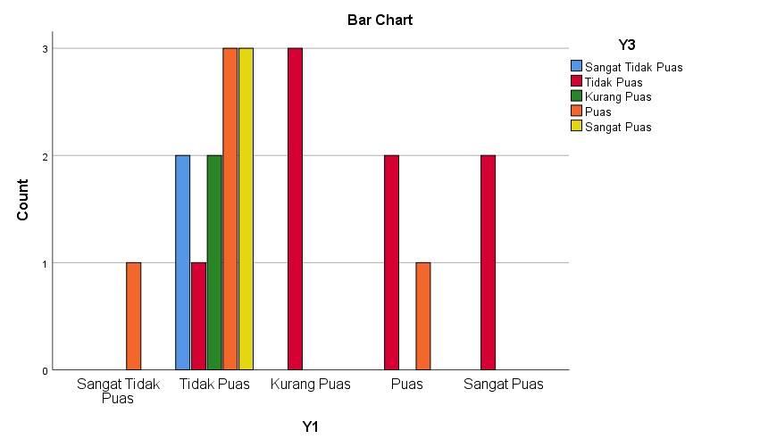

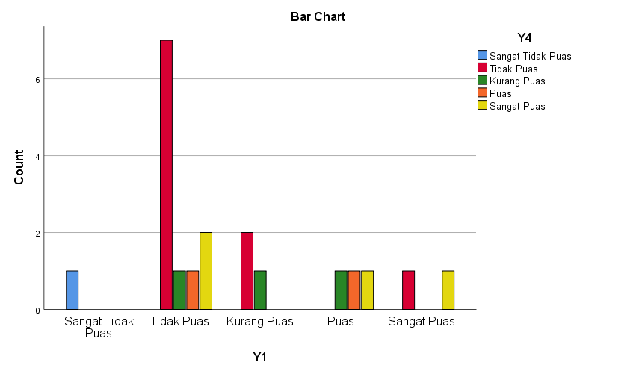

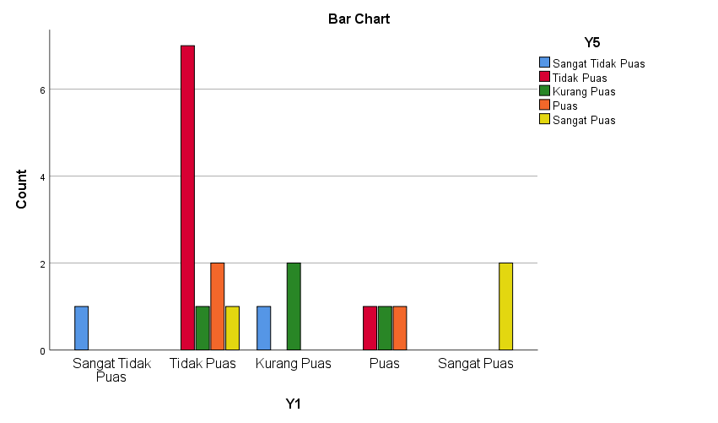

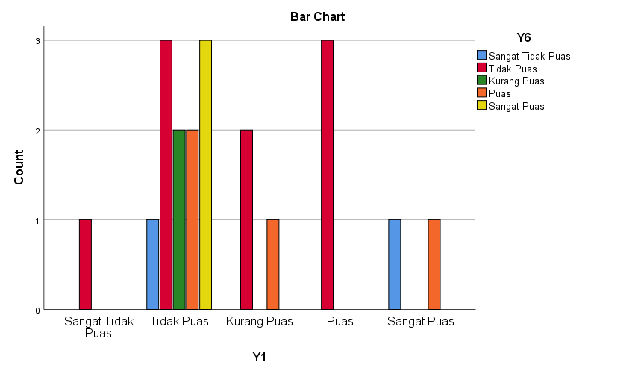

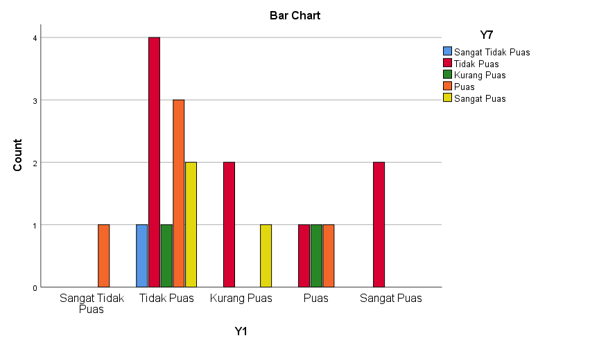

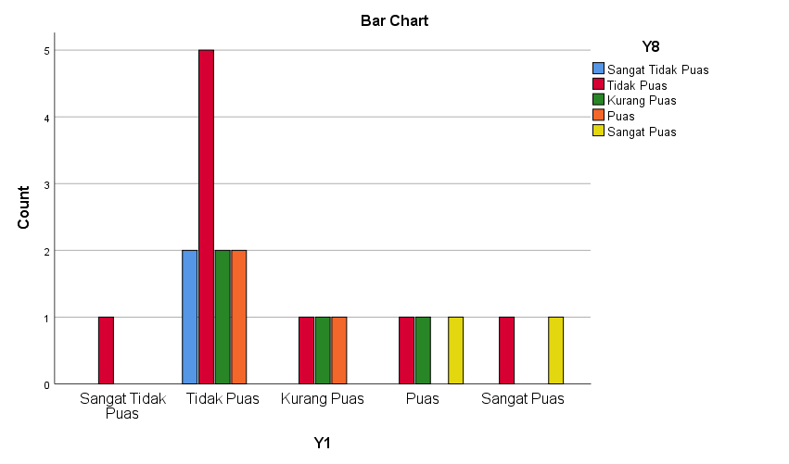

NEW FILE.
DATASET NAME DataSet2 WINDOW=FRONT.
FREQUENCIES VARIABLES=X Y
/STATISTICS=STDDEV VARIANCE RANGE MINIMUM MAXIMUM SEMEAN MEAN MEDIAN MODE SUM
/HISTOGRAM NORMAL
/ORDER=ANALYSIS.

Frequencies

[DataSet2]

Statistics
 |  | Kepuasan Berbelanja di Lazada | Kepuasan Berbelanja di Tokopedia
N | Valid | 20 | 20
N | Missing | 0 | 0
Mean |  | 22,0500 | 22,8500
Std. Error of Mean |  | ,60033 | ,88340
Median |  | 22,0000 | 24,0000
Mode |  | 22,00 | 26,00
Std. Deviation |  | 2,68475 | 3,95068
Variance |  | 7,208 | 15,608
Range |  | 10,00 | 16,00
Minimum |  | 17,00 | 14,00
Maximum |  | 27,00 | 30,00
Sum |  | 441,00 | 457,00

Frequency Table

Kepuasan Berbelanja di Lazada
 |  | Frequency | Percent | Valid Percent | Cumulative Percent
Valid | 17,00 | 2 | 10,0 | 10,0 | 10,0
Valid | 19,00 | 1 | 5,0 | 5,0 | 15,0
Valid | 20,00 | 2 | 10,0 | 10,0 | 25,0
Valid | 21,00 | 2 | 10,0 | 10,0 | 35,0
Valid | 22,00 | 6 | 30,0 | 30,0 | 65,0
Valid | 23,00 | 1 | 5,0 | 5,0 | 70,0
Valid | 24,00 | 2 | 10,0 | 10,0 | 80,0
Valid | 25,00 | 2 | 10,0 | 10,0 | 90,0
Valid | 26,00 | 1 | 5,0 | 5,0 | 95,0
Valid | 27,00 | 1 | 5,0 | 5,0 | 100,0
Valid | Total | 20 | 100,0 | 100,0

Kepuasan Berbelanja di Tokopedia
 |  | Frequency | Percent | Valid Percent | Cumulative Percent
Valid | 14,00 | 1 | 5,0 | 5,0 | 5,0
Valid | 17,00 | 2 | 10,0 | 10,0 | 15,0
Valid | 19,00 | 1 | 5,0 | 5,0 | 20,0
Valid | 20,00 | 1 | 5,0 | 5,0 | 25,0
Valid | 21,00 | 2 | 10,0 | 10,0 | 35,0
Valid | 22,00 | 1 | 5,0 | 5,0 | 40,0
Valid | 23,00 | 1 | 5,0 | 5,0 | 45,0
Valid | 24,00 | 3 | 15,0 | 15,0 | 60,0
Valid | 25,00 | 1 | 5,0 | 5,0 | 65,0
Valid | 26,00 | 6 | 30,0 | 30,0 | 95,0
Valid | 30,00 | 1 | 5,0 | 5,0 | 100,0
Valid | Total | 20 | 100,0 | 100,0

Histogram

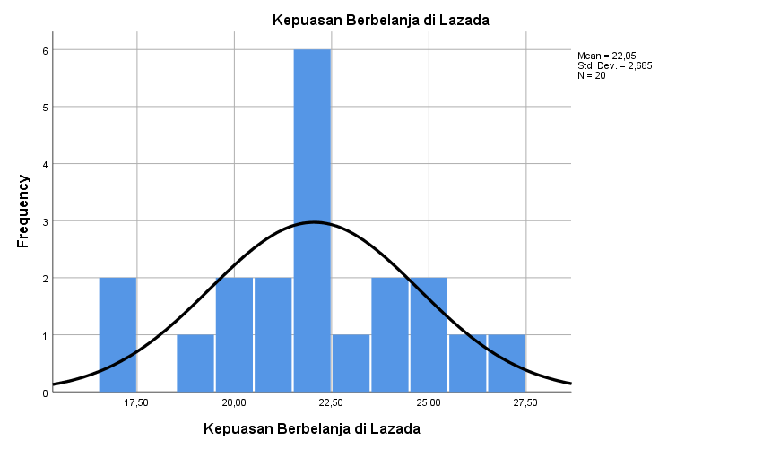

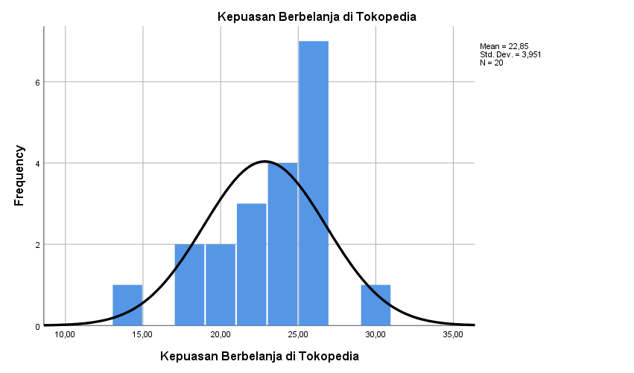

NPAR TESTS
/K-S(NORMAL)=X Y
/MISSING ANALYSIS.

NPar Tests

a. Based on availability of workspace memory.

One-Sample Kolmogorov-Smirnov Test
 |  | Kepuasan Berbelanja di Lazada | Kepuasan Berbelanja di Tokopedia
N |  | 20 | 20
Normal Parameters^{a,b} | Mean | 22,0500 | 22,8500
Normal Parameters^{a,b} | Std. Deviation | 2,68475 | 3,95068
Most Extreme Differences | Absolute | ,157 | ,165
Most Extreme Differences | Positive | ,157 | ,163
Most Extreme Differences | Negative | -,143 | -,165
Test Statistic |  | ,157 | ,165
Asymp. Sig. (2-tailed) |  | ,200^{c,d} | ,161^{c}

a. Test distribution is Normal.
b. Calculated from data.
c. Lilliefors Significance Correction.
d. This is a lower bound of the true significance.

